TestBlackWhite Violations-

1. Local variable 'rainbow' could be declared final

Original-

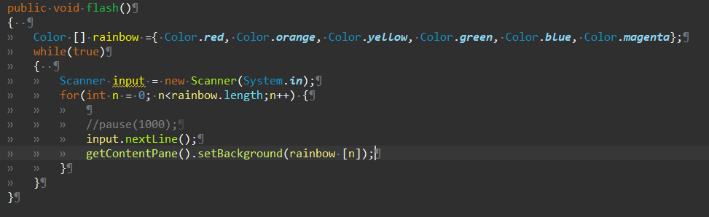

Changed-

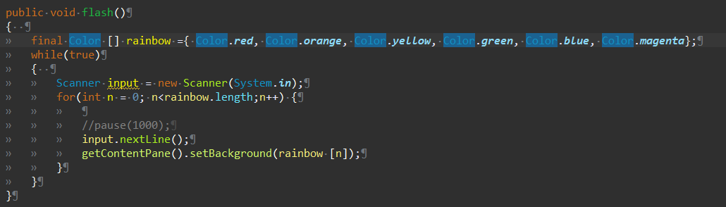

1. Avoid using while statements without curly braces

Original-



Changed-



1. Local variable 'input' could be declared final

Original-



Changed-



1. It is a good practice to call super() in a constructor

Original-

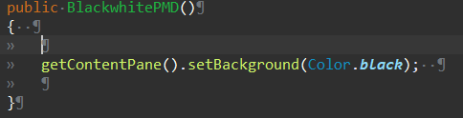

Changed-

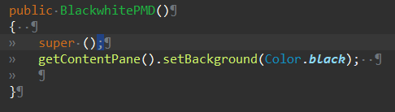

1. Local variable 'startTime' could be declared final

Original-



Changed-



TestWhite Violations-

1. It is a good practice to call super() in a constructor

Original-

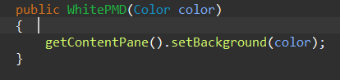

Changed-

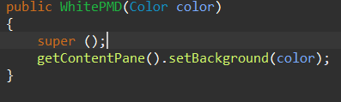

1. Avoid variables with short names like r
2. Avoid variables with short names like b
3. Avoid variables with short names like g

Original-

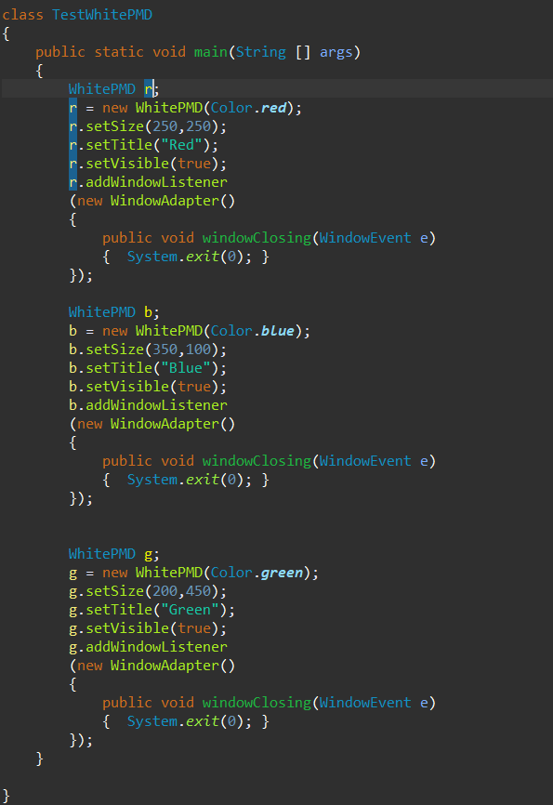

Changed-

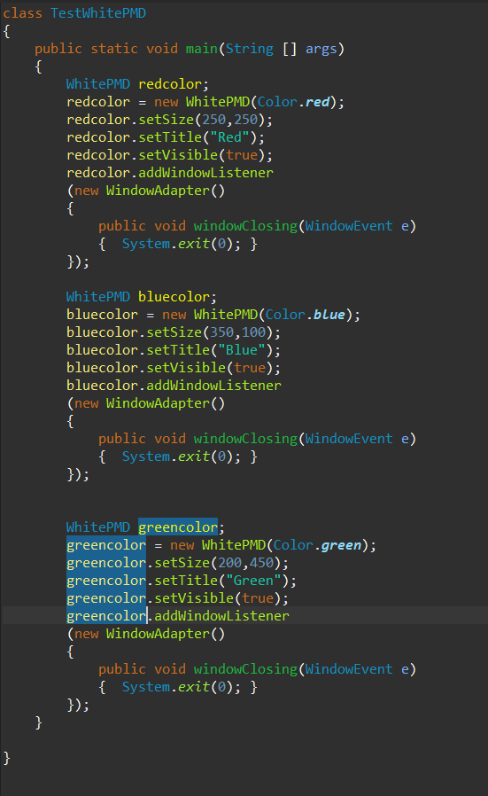

1. Parameter 'color' is not assigned and could be declared final

Original-



Changed-

